CEO, National Security Counsel, LLC
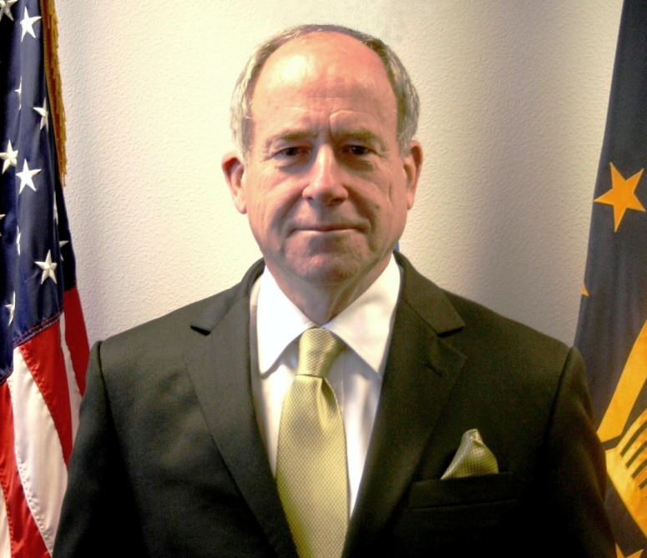

Mr. Robert G. Bell is CEO of National Security Counsel (NSC), a Limited Liability Corporation consulting firm, and Distinguished Professor of the Practice at the Sam Nunn School of International Affairs at Georgia Tech..

Previously, Mr. Bell served as the Senior Civilian Representative of the Secretary of Defense in Europe and the Defense Advisor to the U.S. Ambassador to the North Atlantic Treaty Organization from 2010 until 2017, with responsibility for planning, recommending, and coordinating Department of Defense policies, and programs throughout Europe.

Before assuming that position, Mr. Bell was the Senior Vice President of Science Applications International Corporation (SAIC) from 2004 until 2010. As Account Manager for NATO and the U.S. European Command, he coordinated the business development activities at these organizations of SAIC Business Units in Europe. Mr. Bell chaired SAIC’s European Executive Committee, overseeing a 500% increase in revenues in these accounts during his 6-year tenure, and served as Managing Director of SAIC’s subsidiaries in Belgium and France. In January 2010, he was selected by NATO allies to chair the NATO Industrial Advisory Group (NIAG).

Mr. Bell served as NATO Assistant Secretary General for Defense Investment from 1999-2003. In this capacity, Mr. Bell chaired NATO’s Conference of National Armaments Directors (CNAD) and its C3 Board (NC3B) and directed NATO International Staff activities in the areas of armaments cooperation, missile defense, air defense, airspace management, common funding, and resource policy.

From 1993-1999, Mr. Bell worked at the White House National Security Council (NSC) as a Special Assistant to President Clinton for National Security Affairs and as the NSC Senior Director for Defense Policy and Arms Control. In 1997, he was assigned additional responsibilities as the NSC Counselor.

From 1981-1993, Mr. Bell served on the Senate Committees on Foreign Relations and Armed Services, working four years for Senator Percy and eight years for Senator Nunn. His Capitol Hill experience also includes 6 years at the Congressional Research Service, including a one-year assignment in Brussels, where he served as Staff Director of the Military Committee of the NATO Parliamentary Assembly.

From 1969-1975, he was an Air Force officer in the air traffic control and communications field, commanding a squadron at the age of 24. While a Cadet at the U.S. Air Force Academy, he completed an internship on the Air Staff, commanded the 1969 Outstanding Cadet Squadron, and was commissioned as a Distinguished Graduate.

Robert Bell is a native of Birmingham, Alabama. He holds a Master of Arts degree (1970) in International Security Studies from the Fletcher School of Law and Diplomacy (Tufts University), where he is currently pursuing a PhD. He also holds a Bachelor of Science degree (1969) in International Affairs from the United States Air Force Academy. His professional affiliations include the Council on Foreign Relations and the Air Force Association. Mr. Bell’s awards and decorations include the Department of Defense Medal for Distinguished Public Service (1999 and 2016) and the Air Force Commendation Medal (1973).

Mr. Bell is fluent in French and conversational in Danish, is married to a retired Danish diplomat, Vibeke Roosen Bell, and has 2 sons, Nathan and Stefan, and 3 stepchildren, Adam, Benedicte, and Tobias.

